
Welcome to our April newsletter
As we move through April, it has been lovely to see the gradual change in seasons around us. The brighter mornings, longer evenings and warmer days have brought a renewed sense of energy and positivity across our children’s homes and supported living services. Spring is always a season that encourages growth, fresh opportunities and time spent enjoying the outdoors, and it has been wonderful to see the people we support making the most of this.
We hope you enjoy reading this month’s newsletter and celebrating the many successes from across our services.

FOOTSTEPS CARE
Newsletter – April 2026 Issue



NEWS FROM OUR GOODMAYES ADULT SERVICE
Here in adult services, this month has been full of exciting outings, new experiences and plenty of fun, with everyone making the most of the brighter weather and opportunities to get out into the community and enjoy activities and days out.
We enjoyed visiting a range of local attractions and beauty spots, including trips to Valence House Museum, where we explored local history and enjoyed looking at the different exhibits. We enjoyed a lovely visit to Hainault Forest, where we had peaceful walks, fresh air and spotting wildlife. Visits to Fairlop Waters remained a firm favourite throughout the month, with relaxing walks by the water, opportunities to unwind outdoors and time spent enjoying nature together.
There were also some fantastic trips further afield. A visit to the Tower of London gave us the chance to explore one of London’s most famous landmarks, learn about its fascinating history and see the Crown Jewels. Another exciting day out was spent at the London Sea Life Aquarium, where everyone enjoyed seeing the sharks, colourful fish, penguins and underwater tunnels.
Of course the warmer days graced us with opportunities for beach days. We had trips to Southend-on-Sea which brought lots of smiles, as we enjoyed the seaside atmosphere, walks along the front, arcades, ice cream and taking in the sea air. Looking ahead, there is already excitement building for the upcoming crabbing trip to Canvey Island, which everyone is looking forward to trying together.
Activities this month also focused on health, wellbeing and building confidence in the community. Swimming sessions were enjoyed and bowling trips created lots of laughter and friendly competition, while golf sessions, including visits to Moby Golf, gave us all the chance to practice our swing!
We loved visiting the local parks and Epping Forest, where walks, games and outdoor relaxation helped everyone make the most of the spring weather. As usual, we loved shopping at Lakeside, with food outings being another highlight of the month. We enjoyed meals out in lovely restaurants across different locations, and there was also excitement around attending events at the O2 Arena, giving us the opportunity to experience the atmosphere of one of London’s most iconic entertainment venues.
Alongside community activities, some of us attended church services which were enjoyable and reflective. We are all looking forward to even more adventures and warmer days ahead as we move closer towards summer.

NEWS FROM OUR GOODMAYES CHILDREN SERVICE
What a wonderful month April was for us here in the Goodmayes service. The Easter half term brought a well-deserved opportunity for our children to relax, recharge and enjoy time away from the routines of school after what has been a very busy term.
We enjoyed a fantastic trip to Southend-on-Sea where the children made the most of the seaside atmosphere, enjoying walks along the seafront, the arcades, treats by the beach and taking in the fresh sea air.
We also enjoyed two exciting trips to the local fun fair. We had great fun with lots of laughter and squeals of delight! We enjoyed the rides, games and lively atmosphere together.
As the weather continued to brighten, we spent time enjoying local parks and outdoor spaces, helping everyone stay active while making the most of the spring sunshine. It was nice to be able to wear shorts on a couple of days and feel the sun on our faces.
One of the highlights of the Easter break was our Easter chocolate hunt in the garden. The children had great fun searching for hidden treats before taking part in a range of Easter games and activities together.
We have enjoyed creative activities in the home and use of the garden in the sunshine, particularly the trampoline which is always bouncing fun.
This month also marked an important milestone for one of our children, who moved on to Adult Services. To celebrate this special transition, we hosted a wonderful Bollywood-themed leaving party filled with music, dancing, colourful decorations and lots of joy.
We are also incredibly proud to celebrate an outstanding achievement by one of our children, whose poem has been selected for publication. As part of this achievement, he was presented with an award at school in recognition of his creativity and talent. This was a very proud moment for us all.
Alongside all of the activities and celebrations, we were also pleased to welcome a new child to the home this month. The children and team have worked hard to help them feel welcomed, comfortable and settled as they begin getting to know everyone and becoming part of our family.
We are looking forward to seeing what fun the new month of May will bring us.

OUR MISSION

Working together to create one home, one family.

OUR VISION

We endeavour to ensure every child and young person in our care feels respected, happy, safe, loved, valued, and cared for.
We provide a homely environment which supports children and young people to build on their skills and abilities enabling them to develop greater independence and confidence to take them into adulthood.
We are empowering children and young people with learning disabilities and additional support needs to overcome obstacles and reach their highest potential, whilst promoting welfare and wellbeing.

VALUES

Family, Compassion & Empathy, Safety & Security, Nurture & Empower, Passion, Opportunity.
Our company values are the core principles that define who we are.
We aim to create a healthy culture within a long-lasting, successful, motivating, and safe home where we embrace diversity and uniqueness.
We celebrate great teamwork and foster respect, support, positivity, and kindness.

IMPORTANT DATES

1 May – Early May Bank Holiday (UK)
1 May – International Workers’ Day
3 May – World Press Freedom Day
4 May – Star Wars Day
5 May – Cinco de Mayo
8 May – VE Day
10 May – World Lupus Day
12 May – International Nurses Day
15 May – International Day of Families
17 May – World Telecommunication and Information Society Day
18 May – International Museum Day
20 May – World Bee Day
21 May – World Day for Cultural Diversity for Dialogue and Development
22 May – International Day for Biological Diversity
23 May – Vesak (Buddhist – varies)
25 May – Africa Day
26 May – Spring Bank Holiday (UK)
27–28 May – Eid al-Adha (Islamic – moon sighting dependent)
28 May – World Menstrual Hygiene Day
29 May – International Day of UN Peacekeepers
31 May – World No Tobacco Day

🌙 Eid-al-Fitr 2026 will be at the end of May 2026 (Islam, subject to moon sighting ).

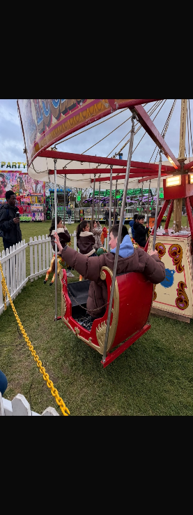

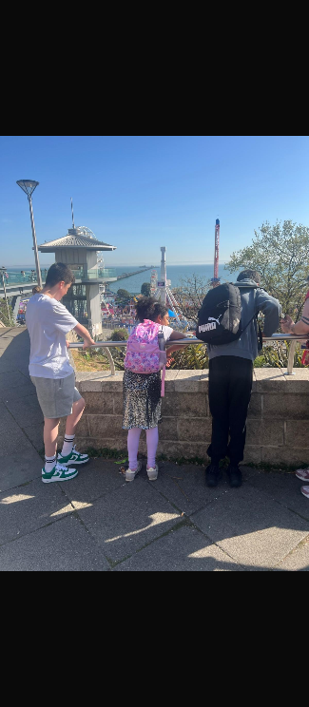
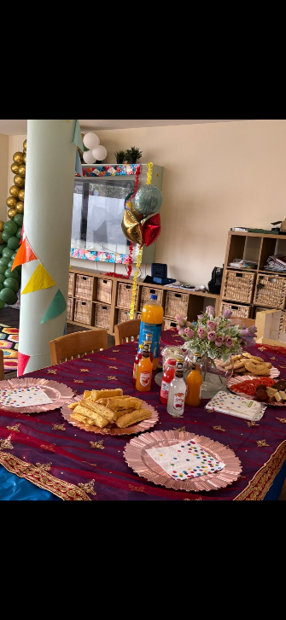

NEWS FROM OUR LEYTON CHILDREN'S SERVICE

At Ambleside our month was filled with fun, celebrations and laughter as we celebrated two of our young people’s Birthday as well as a leaving party for one of our young people who turned 18!

We also had our yearly Autism Awareness Day celebration, which was a great success!
Easter was a lovely fun time with games, a party and a live Easter bunny giving away the Easter eggs!
It has certainly been an extremely busy month for us with so many interesting and fun activities.

Achievements
One of our young people worked well completing a Kids Master IT computer class in which he proudly enjoyed a lovely cap and gown dressed graduation day and was awarded a certificate. Well done young man, we are all very proud of you.

Awareness days and events
The young people engaged in environmental activities in acknowledgement to World Earth Day these included: Hackney Tree Musketeers Nursery, which was based on information sharing and volunteering growing trees to plant in parks and housing estates, also a trip to Leyton Boundary Community Garden, which the young people aways love participating exploring with nature.

Mathematics and statistic month, the young people enjoyed understanding maths from an immersive perspective. A trip to South London’s Maths World was much appreciated in which they engaged in many fun interactive hands-on activities that they learnt from, such as standing in a giant bubble and Kaleidoscope, solving codes, shape solving puzzles amongst many more activities.

With consideration to UN World Health Day and Stress Awareness reflecting on the month the young people took part in many activities that centred around their wellbeing. Starting with a Healthy eating key work session on seasonal fruit and vegetables. A trip to Camden African Network Health Awareness Day was insightful for both the staff and young people which was based on tips to stay healthy.

Arsenal Stadium Museum at the Emirates was an enjoyable experience delving into the History and exploring multiple exhibits of the Football team!! This was enjoyed by all.

Other wellbeing activities included SEND Multi Sports Activities, Eastham Leisure Centre SEND inclusive day, also taking runs on Newham Athletics track, participating in Ability cycling and Junior gym. It was exhausting just watching the children! They all did very well, and participated fantastically.

Places visited that were also appreciated included: Plastow fire station SEND open day, Revel Pucks Circus, a trip to Buckingham palace, visiting London Zoo, exploring Hyde Park and Bayswater. We also enjoyed a Cinema day, group Karaoke, baking and arts and crafts.

Hello and Goodbyes
We say Goodbyes to our well respected and much loved office administrator, Shamus who has moved on to the HR department at Goodmayes, we also send well wishes to Florence on her retirement of whom was a valued member of the night team.
We welcome new office administrator Marios who has made a big warm friendly impression on the team, settling into the office very well. Welcome Marios!

Talk time
This month we have the pleasure of having a chat with our Manager Issac who has worked hard supporting both at Goodmayes and Ambleside homes. Delving into his thoughts, We ask him about what drives him to lead the Ambleside team. he highlighted having the drive to see growth and changes within the young people, also loves challenges and likes to see expected outcomes being achieved through actions, leaving a positive impact within the home.

HEALTH & WELLBEING

All staff members have access to the Care First Zest platform provided by My Possible Self. The platform offers fully confidential Health and Wellbeing Support Services, including 24-hour fully confidential telephone counselling and an interactive health and wellbeing management portal.

RECRUITMENT

If you know someone who would like to join us, please direct them to our website where they can download an application pack to complete and return to
applications@footstepscare.net

STAFF HANDBOOK

Please take the time to read through the staff handbook which can be found on our system, in each office and on our website. The staff handbook contains all the HR policies.

WEBSITE

Our website is regularly updated. To access information about the organisation, commitment to safeguarding, important contact details, newsletters and the gallery, please follow the link below.
https://www.footstepscaregroup.com

YOUR FEEDBACK

Your input means so much to us, and we truly appreciate your thoughtful feedback. The survey is also available on the website. This helps us better understand your thoughts, suggestions, and ideas for improving our workplace. Your feedback plays a key role in shaping our plans for the year ahead. Thank you again for helping us build a better and more inclusive workplace. Stay tuned for updates on our progress and next steps! Click on the QR code and leave you feedback.

POLICIES & PROCEDURES

Our policies and procedures are available to view and read on the FODS system and Footsteps Care Drive. Our core HR policies are also in the staff handbook.


